SET A | SET B
Let Σ = {0, 1}. Consider the following languages over Σ.
L₁ = {w : length of w is odd} | L₁ = {w : length of w is even}
L₂ = {w : w is a palindrome}
L₃ = L₁ ∩ L₂
Now solve the following problems.
(a) Design a Pushdown Automata that recognizes L₁. [5 points]
(b) Design a Pushdown Automata that recognizes L₃. [5 points]
a)  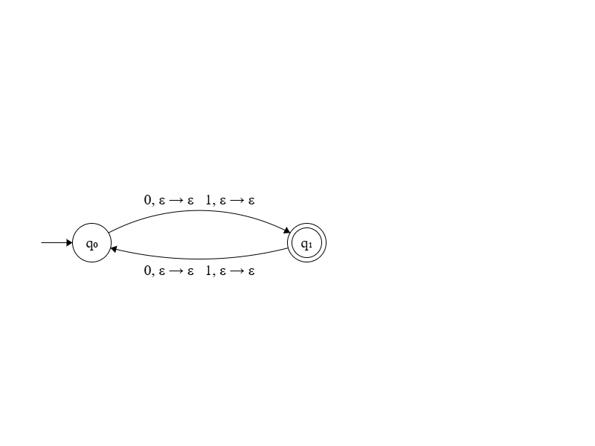 | a)  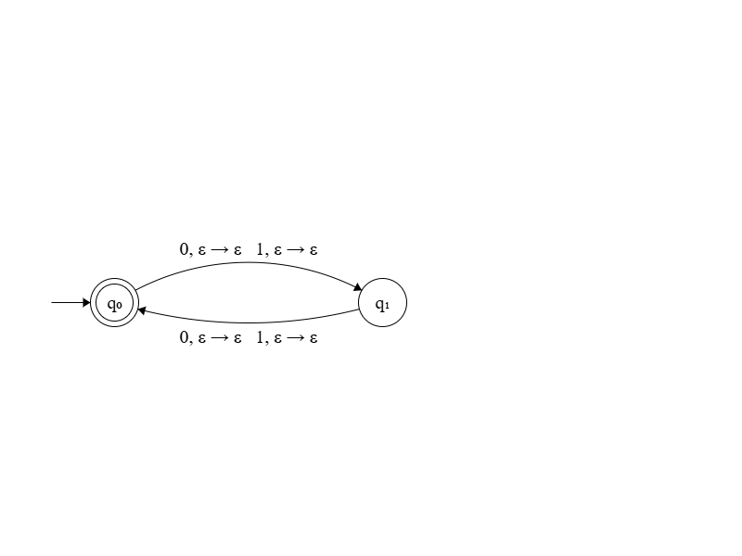
b)  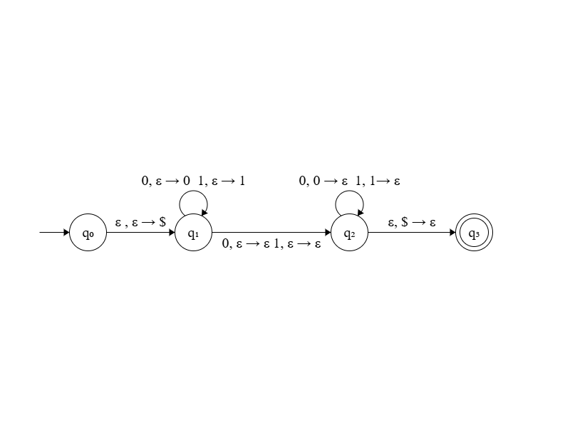 | b)  